## Exercise 3.1: Currency Converter: Special Layout for Landscape

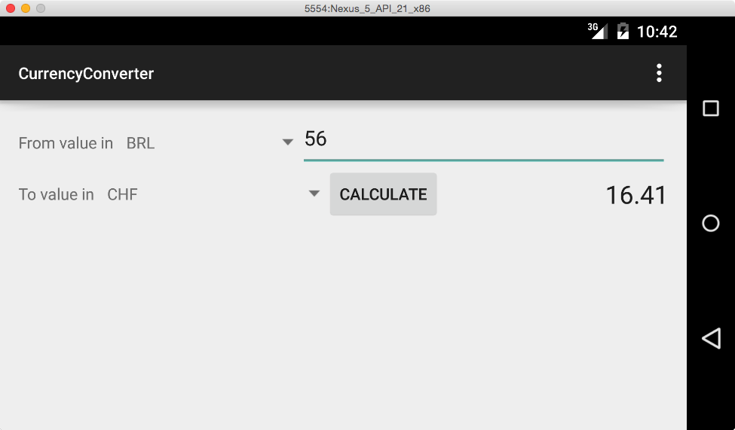

Create a different layout for your currency converter that gets shown whenever the device is in landscape mode.

Create a new layout resource, copy your default layout and adapt it such that everything is arranged in only two rows (see picture above).

Hints:

* You can rotate the virtual device in the emulator using the controls in the bar next to the screen window.

## Exercise 3.2: Your own Launcher Icon for the Currency Converter

Replace the Android robot with an individual icon for the launcher. You can use an image from the web.

## Exercise 3.3: Flags for the Currency Converter

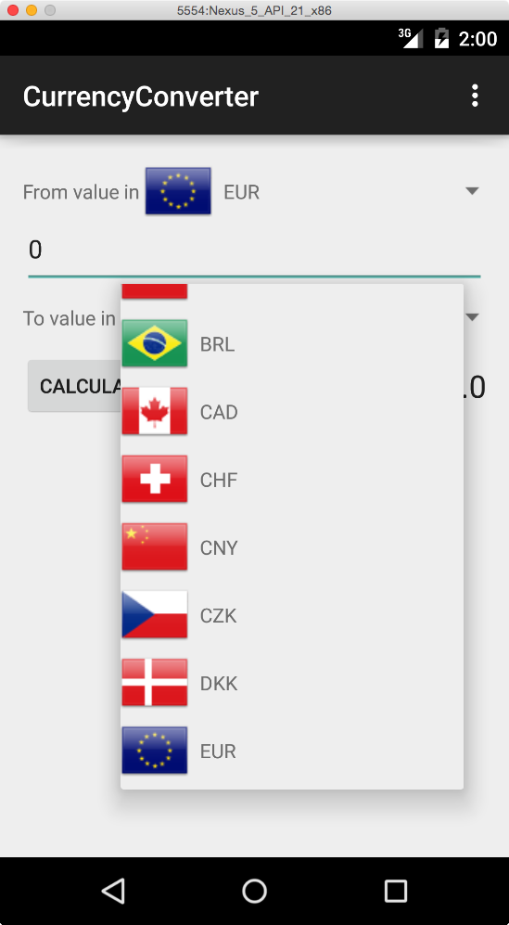

Next we will beautify the interface of our currency converter with flag icons (see picture on the right).

Do the following steps:

1. Load the file flags_cconv.zip from Moodle, unzip the archive an copy the data via *Copy&Paste* to the drawable-folder of your project.
2. Extend the layout for your ListView entries with an ImageView for the flag (width/height 48dp)
3. Implement a custom CurrencyItemAdapter that creates View objects that contain flag and text (Layout: LinearLayout horizontal), or extend the adapter from exercise 2.5.
4. Use CurrencyItemAdapter instead of ArrayAdapter for the Spinner views as well as the ListView from exercise 2.4.

Remarks:

* Possible starting point for your adapter implementation:

public class CurrencyItemAdapter extends BaseAdapter {

ExchangeRateDatabase rateDb;

public CurrencyItemAdapter(ExchangeRateDatabase db) {

rateDb = db;

}

@Override

public int getCount() {

// TODO

}

@Override

public Object getItem(int position) {

// TODO

}

@Override

public long getItemId(int position) {

// TODO

}

@Override

public View getView(int position, View convertView, ViewGroup parent) {

Context context = parent.getContext();

String currencyName = rateDb.getCurrencies()[position];

// TODO: (Create and) Initialize view with text and image

}

}

* The flag image resources are named following this schema: flag_*<<ShortCodeOfCurrencyInLowerCase>>* (f.e. flag_eur)
* String.toLowerCase() converts a string to lowercase.
* The resource id of a drawable which you have the name of as a String can be obtained using:

int imageId = context.getResources().getIdentifier(*<<Name of resource>>*, "drawable", context.getPackageName());